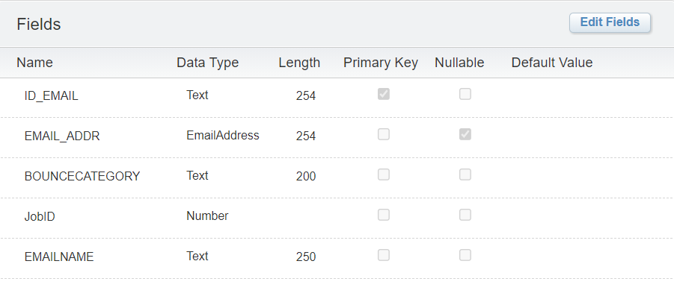

SELECT DISTINCT

s.SubscriberKey AS ID_EMAIL

, LOWER(s.EmailAddress) as EMAIL_ADDR

, b.BounceCategory

, jb.jobid

, jb.EmailName

FROM _Subscribers s

JOIN _Bounce b ON b.SubscriberKey = s.SubscriberKey

JOIN _Job jb ON jb.jobid = b.jobid

WHERE lower(b.BounceCategory) = 'hard bounce'